Studio Practice Group Report

*GAME DESIGN*

*Role Description*: According to the Creative Skillset “Game Designers devise what a game consists of and how it plays. They plan and define all the elements of a game: its setting; structure; rules; story flow; characters; the objects, props, vehicles, and devices available to the characters; interface design; and modes of play. Once the game is devised, the Game Designer communicates this to the rest of the development team who create the art assets and computer code that allow the game to be played.” In the context of your project – you may be using an existing game design and contextualise in your project – e.g. emphasising the impact of localisation; or, exploring the correlation between the chosen game design and the emotional impact it has on a player – depending on the project in hand.

*Deliverables:* an adapted game design, with the emphasis on the elements relevant to the project (e.g. localisation, or incorporating feedback obtained from measuring the emotions when game is played); design document (typically, 2-3 pages A4, or up to 1500 words plus graphical content and appendices) containing synoptic and diagrammatic description of the game itself including the enhancements introduced to address the localisation challenges, or biometric data related findings.

DESIGN LEAD

*Role Description*: take the leadership of the design process and lead on the design solution; perform research (or use one if a Researcher role co-exists in the team) in the field of the project to inform the design solution; use design principles as appropriate in the field of the project to produce design artefacts; take responsibility for providing a design document and lead on producing one; provide references to the sources used in the process

*Deliverables*: design artefacts as required in the project; design document (typically 2-3 pages, A4, or up to 1500 words plus graphical content and appendices), with illustrations, diagrams, scenarios etc – as appropriate for the project – to be added as part of the Report

# Game Design Group Report

At the beginning of the project the group got our selection of project briefs which included interaction within games, services for museums, augmented reality based and healthcare. After a couple group meetings as well as a simple voting system we went for a mobile gaming app towards transforming healthcare. We looked at both the given briefs and their requirements to see how we can merge them together to create a healthcare application.

## Initial Game/ App Idea

Once we got our idea of creating a mobile application towards “transforming healthcare” brief approved we got to work brainstorming potential ideas which would be combatable to the brief given to us. We came up with some ideas relating to food nutrition and weight loss programs but they have been done millions of times, so in an attempt to stand out for our vast competition our group looked into bringing augmented reality to the app.

## Final/ Chosen Idea

After a couple weeks’ worth of research towards current competitors and ow to stand out using augmented reality we chose to design the app around diabetes type 2 (Insulin one). This app will help the users track how much insulin they’ll need during the day and why they need it. This in the long term can help reduce the usage and improve the diets of the users.

This app also allows the users to scan any food and drink products by taking a photo of the item and the app will then show you its nutrition, its ingredients, rating out of five towards your current state and a photo of the product.

## Adding Gamification

Whist the group leader and UX designers researched into augmented reality and how we can include it into the application myself and our game animator where tasked to find a way to include gamification towards the app to help attract more users. We looked into ways previous apps of similar nature have tried to add this feature as well as software sure as Microsoft.

## Research towards App Avatars

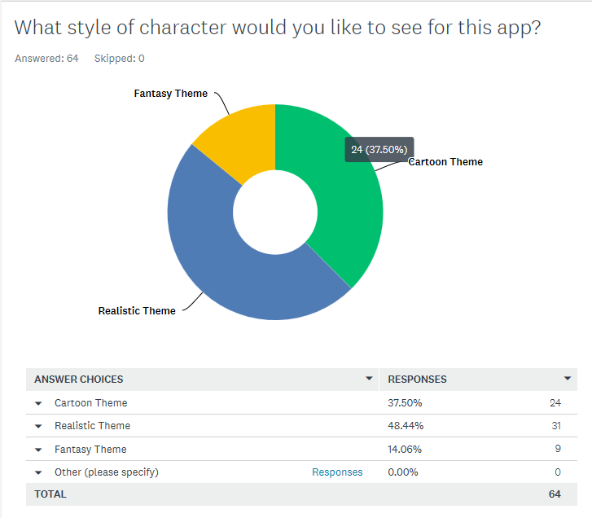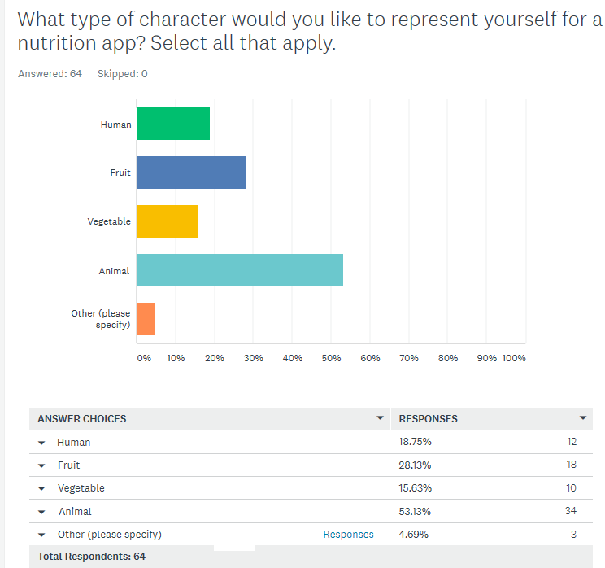Our initial research we learned players don’t like to have a character on their screen which has no purpose such as the paperclip from Microsoft Word so we chose to create a simple survey on Survey Monkey to get some results from the general public what they would like to see in a nutrition app. Results are shown below:

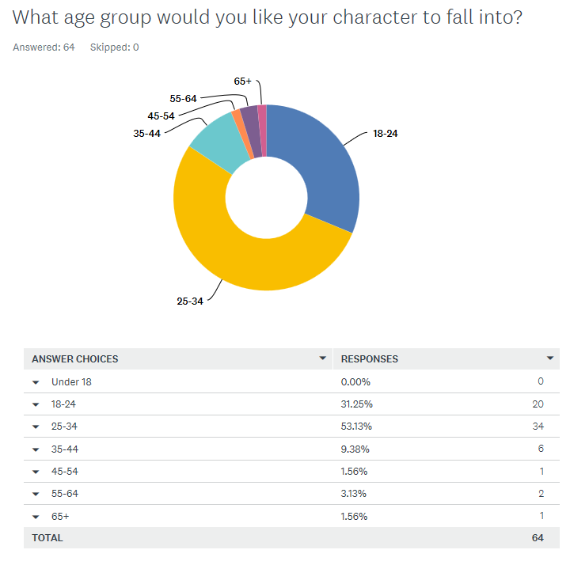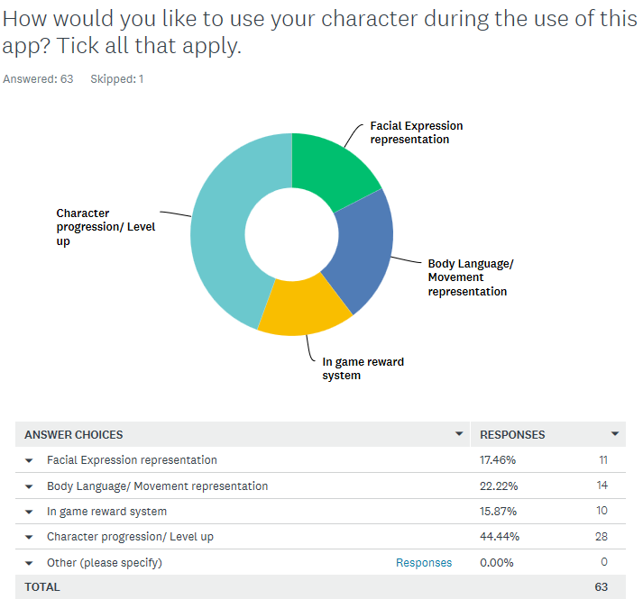

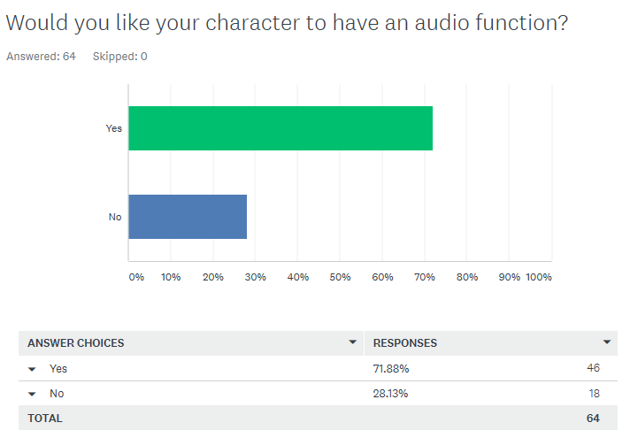

From these five questions I and our games animator know to create a game avatar which is an animal or a fruit which is designed in the realistic theme, has a progression or levelling up system, suitable for adults in the range of 18-34 and has audio systems included. This really helped decide what do design and how.

# Designing the Avatar

Using the survey data received, as a group we decided to create an avatar using a fruit base form with realistic facial and clothing features. This is due to myself not being able to 3D model animals to well and wished for this feature to encourage players to keep using our app. We did some research towards potential designs by showing mood boards and current avatars in animated movies. After this we chose to create a realistic looking Avocado with arms, head/ hair and a face.

## Creation of the Avatar

The software I used to create the avatar was Maya 2019 due to it being easier to use its available tools to animate the character once it was complete. To create the base of the avocado I used a sphere and then stretched out the top half and width at the bottom half to give the impression of the top and bottom part of the body. I then cut the model in half and attached the nut on the lower third of the body.

## Creation of Avatar features

### Eyes

When the base of the avatar was complete I started with the facial features and arms. To complete the eyes I got another sphere and shaped it using the body nut as a guide and then duplicated them to create the eye lids. I then attached two spheres to the eye lids to create the eye and pupils, I was asked to keep them unattached to each other so they are easier to animate.

### Mouth & Hair

I then worked on the hair of the avatar and decided ill add a stem with a couple leaves which can then be animated to move or whist wearing hats can be squashed inside. I did this by using the extrude tool from the top of the model and adding several segments so I can add the leaves. The mouth was done by creating a box with several segments and a tongue, once that was done I used the smooth tool.

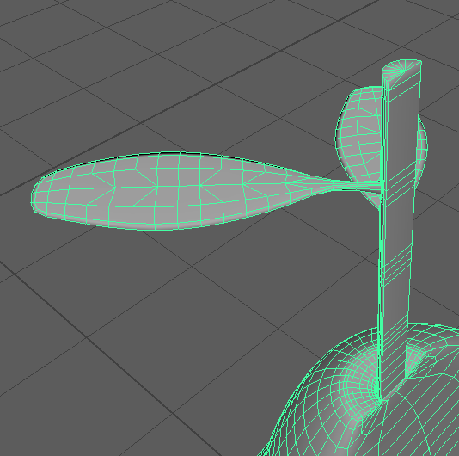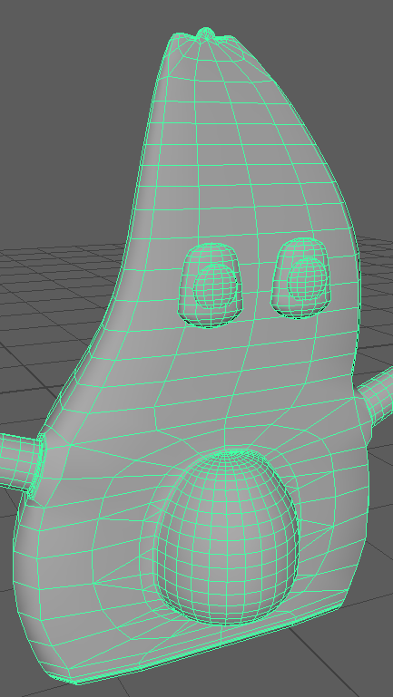

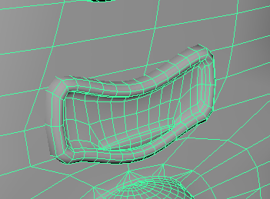

* Customisation assets
* Texturing
* Challenges (Arms that didn’t work, eyes not combatable),
* what Iv learned (Maya tools, organic modelling)
* Conclusion